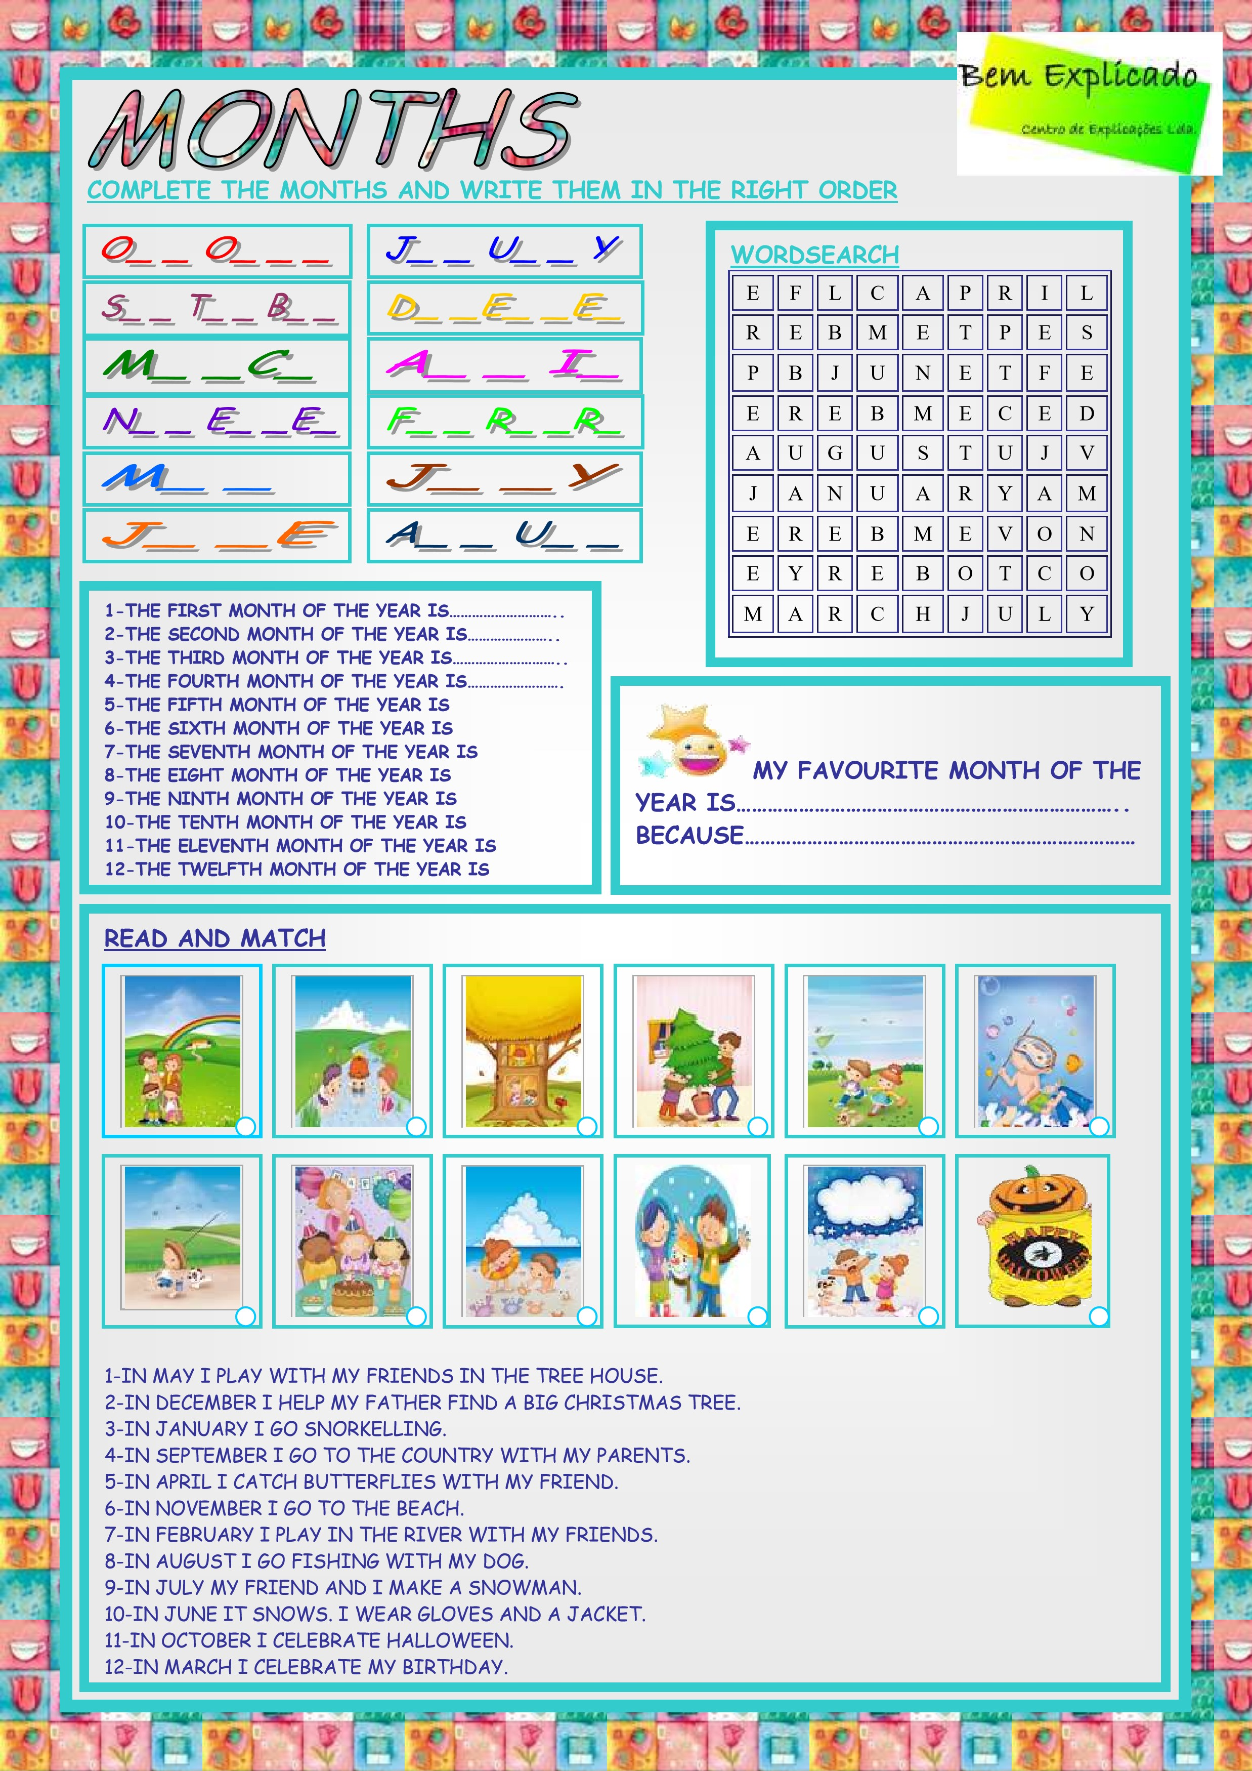

9

10

11

12

6

8

3

5

2

7

4

1

July

Of Christmas

December

December

November

October

September

August

June

May

April

March

February

January

August

July

February

April

December

January

May

November

March

September

October

June